
BAKERSFIELD COLLEGE

Electronics

Raspberry Pi Pico

Project 03：External LED Flashing

1. Introduction:
In this project, we are going to show you the external LED flashing effect. We will use the Raspberry Pi Pico's digital pins to turn on the LED and make it flash.

2. Components:
Raspberry Pi Pico Red LED 220Ω Resistor Breadboard

3. Knowledge:
The LED is a semiconductor called “light-emitting diode”, which is an electronic device made from semiconducting materials (silicon, selenium, germanium, etc.). It has an anode and a cathode. The short lead is cathode, which connects to GND, the long lead is anode, which connects to 3.3V or 5V.

The Resistor (220Ω) will be used as a current-limiter to restrict or regulate the flow current flow to about 20ma.
A breadboard is used to build and test circuits quickly before finalizing any circuit design.
When we connect DIP (Dual In-line Packages) components, such as integrated circuits, microcontrollers, chips and so on, we can see that a groove in the middle isolates the middle part, so the top and bottom of the groove is not connected. DIP components can be connected as shown.

2. Wiring Up
In this project, we use a USB cable to connect the Raspberry Pi Pico to the computer.
(do this connection after you have wired the circuit and double check your wiring)
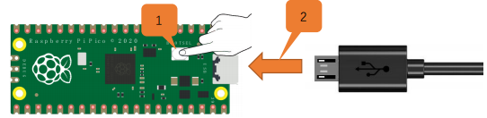

Raspberry Pi Pico USB Cable

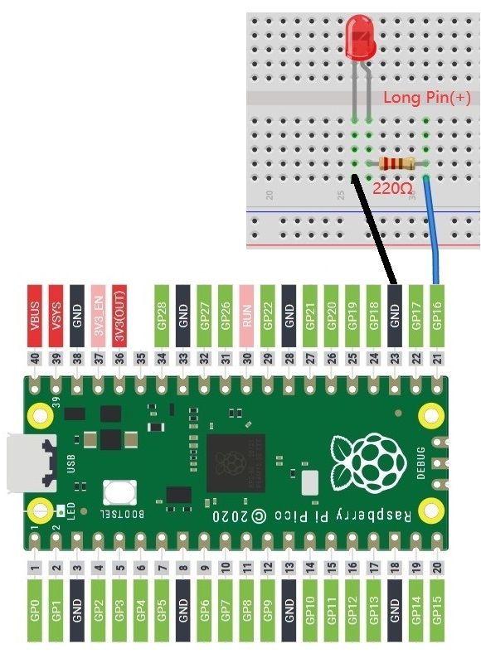
4. Circuit Diagram and Wiring Diagram
First, cut all power to the Raspberry Pi Pico.

Then build the circuit according to the circuit diagram
and wiring diagram.

After the circuits are set up and verified, using a USB
cable to connect the Raspberry Pi Pico to a computer.

Note: Avoid any possible short circuits (especially
connecting 3.3V and GND)!

Warning: A short circuit may
cause a large current in the
circuit, causing components
to overheat and permanent
damage to the Pi.
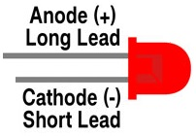

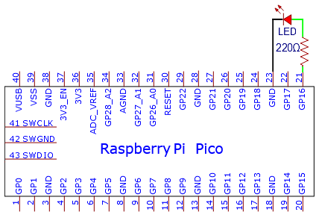

This is the schematic of the circuit:

3. Test Code
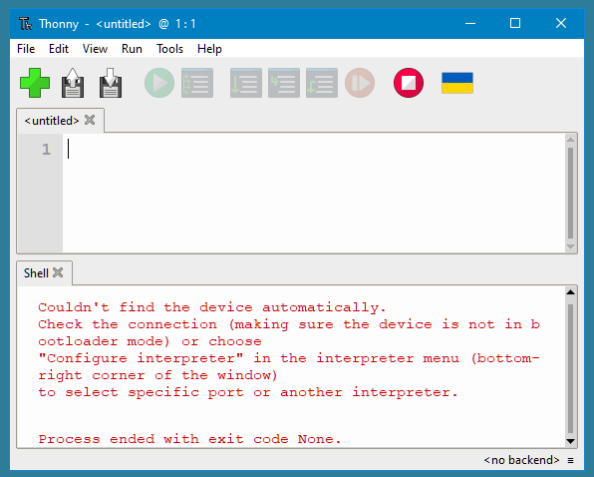
Connect the pico board to the PC, then open, Thonny is a free, easy and open-source integrated development environment (IDE) with Python built-in that is designed for us beginners to learn programming.

It supports compiling or debug programs.

In the "Shell" window, you can view the error information and output results generated during the running of your program, and you can query step-by-step expression evaluation, detailed visualization of the call stack and a mode for explaining the concepts of references and heap to help improve the compile program.

The Thonny (IDE) will be used for all the Raspberry Pi Pico – Projects.


When you first open ‘Thonny IDE’ it will look like this: (Because the Pi is not Plugged-in.)

After the Pi is Plugged-in click the: “Stop /Restart backend”

The ‘Thonny IDE’ will look like this: (Because the Pi is Plugged-in)
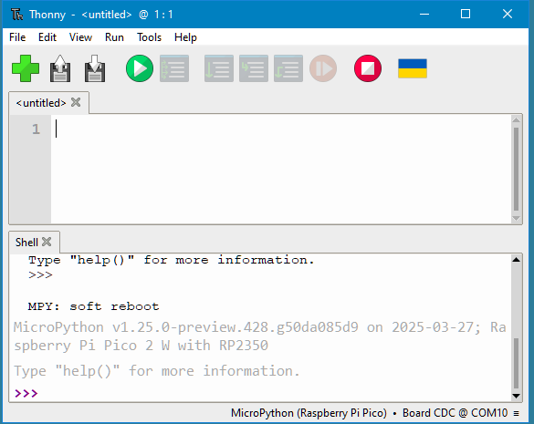

The ‘Thonny IDE’ it will display the Pi and the IDE with Python. ↑
At this point a program could be type-in or it can be loaded from a file.

Go ‘File’ then ‘Open’ or click “Open...”

Click ‘This computer’.
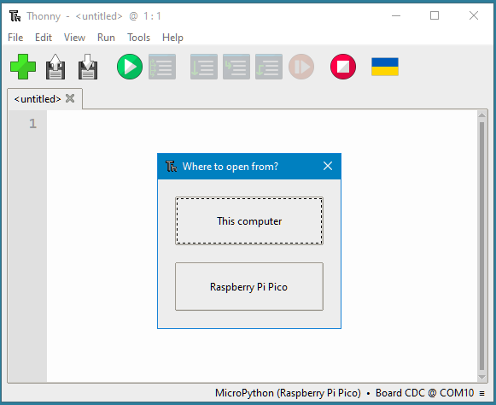

and choose the file to load. (#03 - LED Flashing External #1.py)
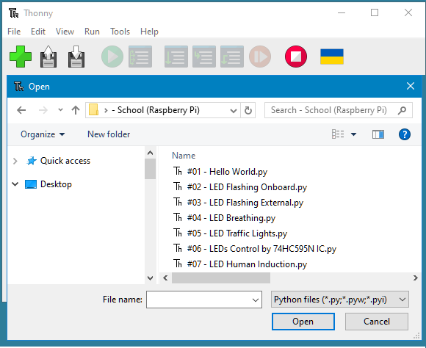

The IDE will look like this:
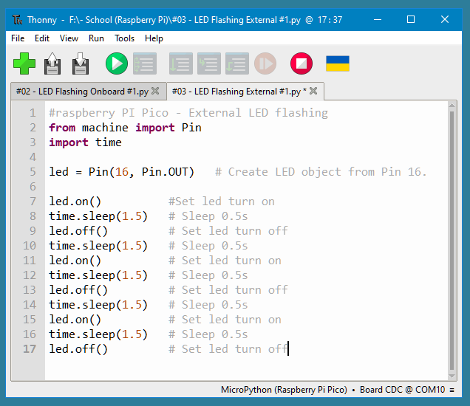


Now click the ‘Run’ then ‘Run current script’ or click the:
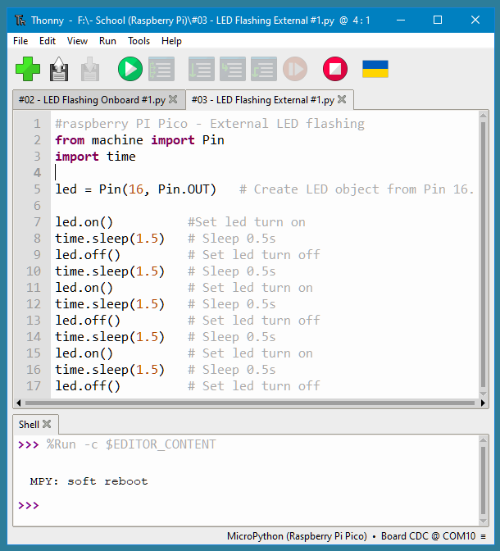

The bottom half (Shell X) of ‘Thonny’ will not have a display output, but the onboard LED on the Raspberry Pi Pico will blink on and off 4 times.

Note: The code here runs offline.


If you want to Stop running offline and display the information in the “Shell” window, simply click in Thonny software.



There are two (2) different code versions of the: LED Flashing Onboard.

You may want to add your own touches and modifications to come-up with other versions and timing intervals…

